Table of Contents

Table of figures 1

Introduction 2

How Deep Learning Algorithms “Learn”? 2

Limitations of Deep Learning 4

Literature review 5

System Architecture 6

AI techniques 8

AI technique used for the system 12

Conclusion 12

**References** 13

Table of figures

Figure 1 Neural nets (Liang, 2018) 3

Figure 2 Function used to pass information (Liang, 2018) 3

Figure 3 Loss function (Liang, 2018) 4

Figure 4 System architecture of handwritten character recognizer 7

Figure 5 Stages in OCR (Sahu & Kudbe, 2012) 7

Figure 6 Dataset (Sahu & Kudbe, 2012) 7

Figure 7 Zoning (Sahu & Kudbe, 2012) 8

Figure 8 Graphical representation of a biological neuron (left) and an artificial neuron (right) (Diepen, Everlo, & Bouazzaoui, 2017) 9

Figure 9 Seven categories of tasks ANN can perform (Jain, Mao, & Mohiuddin, 1996) 11

Introduction

The emerging buzz word in the tech community of this century is Deep Learning. Even though we tend to listen to this word in daily basis, most of the people doesn’t have a clear understanding about this technology; people don’t know what exactly is AI (Liang, 2018). Basically, most of the people have the sound knowledge of AI but they don’t actually know what is behind AI or what AI is as a whole.

Generally speaking Deep Learning in simple is a machine learning technique that helps to predict the output Y when an input of X is given. For example, if given the stock prices of this month as the input for a deep algorithm that has been trained to predict the stock prices, it will predict the stock price for the next coming month by machine learning the patterns of stock price changes in a month. (Liang, 2018)

Given a large dataset a deep learning algorithm will always try to reduce the difference between the expected output and the prediction (Liang, 2018). By doing this it tries to achieve an acceptable degree of accuracy for the deep learning algorithm.

How Deep Learning Algorithms “Learn”?

Neural networks are used by deep learning algorithms to find the associations between the inputs Vs outputs. Basic structure is shown below:

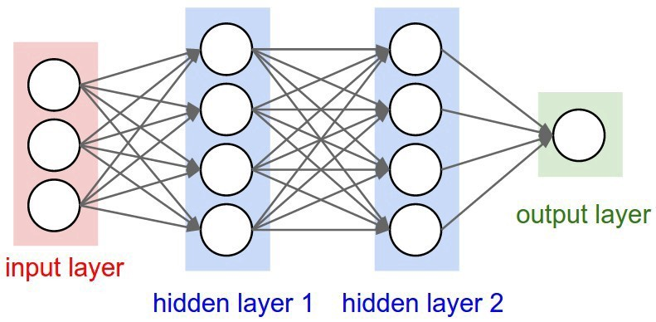A neural network consists of three main layers;

Figure Neural nets (Liang, 2018)

* Input layer – takes0in0a0numerical0representation0of0data (e.g.: images0with0pixel0specs)
* Hidden layer - correlated0with0most0of0the0computation.
* Output layer - output0predictions (Liang, 2018).

All of these are composed of “nodes”.

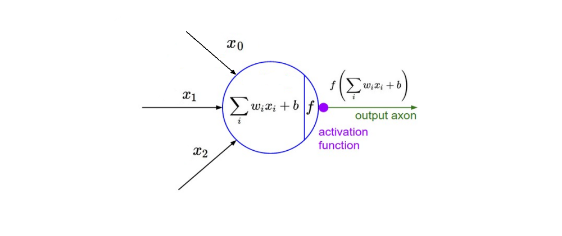

Figure Function used to pass information (Liang, 2018)

The important points to note here from the above given function are the tuneable weights (w)0 and0 bias(b)0parameters. These are important in the process of actual learning of the model (Liang, 2018).

After the neural net passes its inputs to all the way to its outputs, the network will evaluate how good the predictions were depending on the expected output by using the “Loss function”.

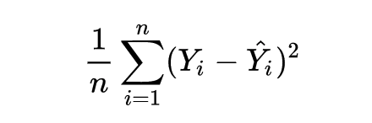

Figure Loss function (Liang, 2018)

$\hat{y}$– prediction

Y – expected output

n0- sample count

The ultimate goal of a deep learning algorithm is to reduce the loss by adjusting the w (weight) and the b (bias) of the given network. There’s a technique called the “Back Propagation” in which the network backtracks through all it’s layers by changing and updating its weights and biases of the nodes to reduce the loss function. In other words, in every iteration of the back propagation the loss function will be less than the previous value (Liang, 2018).

Deep learning is an expansive field ultimately and is far more complex than mentioned here. There are different types of neural nets depending on their tasks to be performed. E.g.:

* Convolutional Neural networks (CNN) – used for computer vision.
* Recurrent Neural networks (RNN) – used for natural language processing. (Liang, 2018)

Limitations of Deep Learning

Deep learning is mainly used for solving classification problems as they are remarkably powerful on those situations (Ray, 2018). But not all the problems that we need to apply deep learning are not classification-based problems. There are some common limitations of deep learning, those are as follows,

* Lack of common sense.

Acting intelligently in day to day situations is known as common sense. It is the ability to make conclusions even with minimum experience. This cannot be performed using a Deep Learning algorithm as it uses training methods to draw decisions using their previous experiences (Ray, 2018).

* Lack of understanding on exact underline laws of input data.

Deep learning algorithms are based on continuous training of network and data, on this basis we can only conclude the output and it cannot guarantee 100% accuracy (Ray, 2018). Therefore, only estimations are made.

* Lack of general intelligence and multiple domain knowledge integration.

There are situations where a deep learning model provides an embarrassing wrong output. This is due to the fact that the data that has been fed to the model for training must have been erroneous (Ray, 2018). In general, the human intelligence accelerates due to the connectivity of other people, therefore a deep learning model is expected to output wrong information in a situation where a wrong input is fed for training (Ray, 2018).

* Unable to learn from limited examples.

A deep learning model works well when the training dataset is huge (Ray, 2018). This is because the number of examples fed to the model gives the model a better understanding on what to predict. In other words, the model’s intelligence is dependent on the dataset that is been fed to it. Therefore, these cannot be applied for dynamic problems (Ray, 2018).

Literature review

Immense research is currently going on in the field of handwritten character recognition (Vaidya, Trivedi, & Satra, 2018). Many people have developed several applications to perform handwritten character recognition. Some of such systems:

Using Fuzzy logic recognizer, a character recognition system has been designed (Lu, Li, & Shi, 1995). The system created them can be done on a VLSI structure. The system is immune to distortion and variance in shift. The use of hamming neural network can be seen in their solution (Vaidya, Trivedi, & Satra, 2018).

There is another presented system that will use a unique method to identify a person based on their handwriting (Murthy, 1999). Multi-layer feed forward neural networks have been used to develop his system. This author has mentioned in his research paper that “the height and width of a handwritten alphabet is unique for each and every person” (Murthy, 1999).

(Vaidya, Trivedi, & Satra, 2018)

An innovative method without using feature extraction to perform handwritten character recognition has been presented by another author (Pradeep, Sirinivasan, & Himavathi, 2011). Matlab is been used in their system and it uses a feed forward neural network with backpropagation (Vaidya, Trivedi, & Satra, 2018).

In the proposed system ANN (Artificial Neural Networks) will be used. ANN is the human brain inspired system, who’s intension is to replicate the way the human learns. Human brain works adaptively to certain different changes of its environment, by using a similar approach an appropriate model must be able to produce similar responses by reproducing the human neurons system (Mahmoud, 2015).

System Architecture

Input image

Pre-processing of the image

Segmentation

Feature extraction

Training the neural network

Classification and recognition

Display image

Figure System architecture of handwritten character recognizer

Offline handwritten character recognition system is built on the basis of pattern recognition, and pattern recognition basically have three main steps: observation, pattern segmentation and pattern classification (Sahu & Kudbe, 2012).

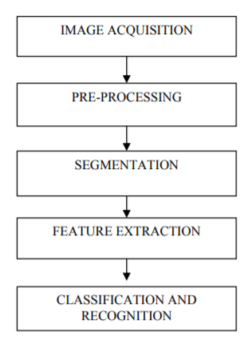

Figure Stages in OCR (Sahu & Kudbe, 2012)

Phases of character recognition system

Followings are the steps involved;

* Image acquisition

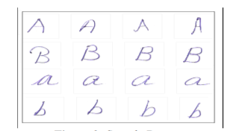

Figure Dataset (Sahu & Kudbe, 2012)

* Pre-processing

The process of doing a series of operations that will be performed on the inputs are known as the pre-processing. This will necessarily improve the image rendering for segmentation (Sahu & Kudbe, 2012). There are various steps in pre-processing namely; Noise reduction, Binarization, Edge detection, Thresholding, Skew detection, Slant Estimation and Normalization (Sahu & Kudbe, 2012).

* Segmentation

This is the most important process in character recognition systems. This process is done in order to make the separation between individual characters of an image (Sahu & Kudbe, 2012). There are two types of segmentations namely; external segmentation and internal segmentation.

* Feature Extraction

The process of extracting the most important data from the raw data in known as the feature extraction. By most important data what it is been meant is the basis that which can be used to represent a character accurately (Sahu & Kudbe, 2012).

Major objective of feature extraction is to extract a set of features, that will help to increase the recognition rate with minimum number of elements.

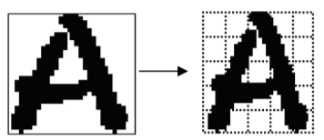

Figure Zoning (Sahu & Kudbe, 2012)

* Classification and Recognition

This stage is the decision making component of the offline handwritten character recognition system and this stage uses the features that has already being extracted in the feature extraction stage.

AI techniques

AI mimics the human brain when solving complex problems, learning and reasoning (Chen, Jakeman, & Norton, 2008). There are a range of AI technologies available. Some of them are namely;

* Case-based reasoning (CBR).
* Rule-based systems (RBS).
* Artificial neural networks (ANN).
* Genetic algorithms.
* Fuzzy models.

(Chen, Jakeman, & Norton, 2008)

Case Based Reasoning (CBR)

Case based reasoning is the technique that uses previous experiences to recall similar past problems to solve problems assuming that they have similar solutions (Chen, Jakeman, & Norton, 2008). For these to perform well, they need large amount of past cases so that it can adapt its solutions or methods to solve new problems. This basically have 4 steps; retrieve, use, revise, retain (Chen, Jakeman, & Norton, 2008).

Rule Based Systems (RBS)

RBS works in order to solve problems using the rules defined by expert knowledge (Roth, 1985). Rules generally have0 condition0 and0action0parts. 0If0and0then0statements are fed to an inference engine, with an active memory of the information regarding the problems, a pattern matcher and a rule applier (Chen, Jakeman, & Norton, 2008). 0Rules0and facts are imprecise.

Artificial Neural Networks (ANN)

Artificial Neural Networks practise the way that human brain processes the information that feds to it (Chen, Jakeman, & Norton, 2008). It has several processing units named as neurons or nodes working simultaneously. These neurons/nodes are highly interconnected through synapsis – the links, with weights. These are arranged in layers known as input layer, hidden layers and the output layer with links to the neurons in other layers (Hammerstrom, 1993). Artificial Neural Networks require some of assumptions beforehand, learning from examples via adjusting the connection weights (Chen, Jakeman, & Norton, 2008).

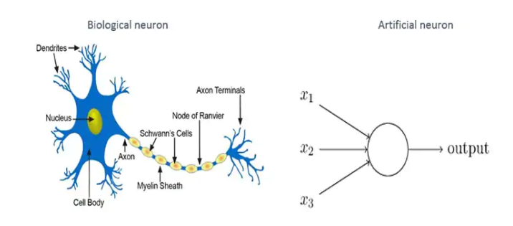

Figure Graphical representation of a biological neuron (left) and an artificial neuron (right) (Diepen, Everlo, & Bouazzaoui, 2017)

Learning is either supervised or unsupervised. Supervised learning tends to give accurate output for all the input patterns. To reduce the error, i.e.; the difference between the Artificial Neural Network output vs the expected output, the weights are been adjusted. Reinforcement learning is another form of supervised learning which tells the Artificial Neural Network if the output it gives is correct rather than giving an expected output (Yao, 1999).

What happens in unsupervised learning is that the Artificial Neural Network gets several input patterns. Artificial Neural Network then analyse the relationship between the patterns and categories them by learning. There are situations where the developers decide to combine supervised and unsupervised learning (Chen, Jakeman, & Norton, 2008).

Mostly the Artificial Neural Network technique is suitable when it has to solve more0intensive problems0where0the0algorithm0to0solve0the0problem is unknown or troublesome to interpret (Zhang & Stanley, 1997).

Artificial Neural Network become a good fit for complex and multivariable data by its data structure and non-linear computations (Chen, Jakeman, & Norton, 2008). Data errors are robust in Artificial Neural Network as it processes information parallelly. They have the ability to generalize by exploring relations depending on0imperfect0data0as0long0as0they0do0not0have0enough0nodes or neurons to overfit data imperfections (Chen, Jakeman, & Norton, 2008).

One of the main disadvantages of Artificial Neural Network is that it is considered as an uninformative black- box model, and thereby becoming not suitable for problems that require process explanations (Chen, Jakeman, & Norton, 2008). Therefore, if an Artificial Neural Network fails to assemble, there is no method to figure out the course for it.

Use of Artificial Neural Networks are seen mainly on 7 different problem categories (Chen, Jakeman, & Norton, 2008);

* Pattern recognition.
* Clustering. 0
* Function0approximation/ Regression.
* Prediction. 0
* Optimization 0.
* Retrieve by content.
* Process 0control.

(Jain, Mao, & Mohiuddin, 1996)

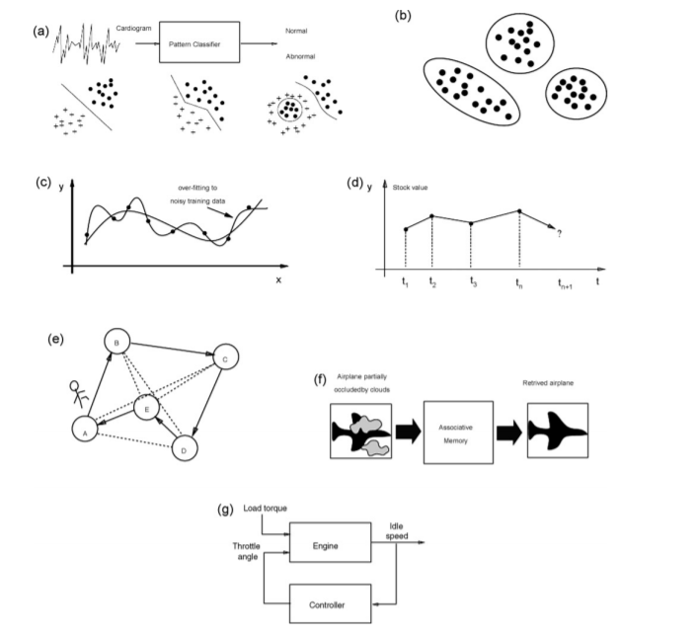Pattern classification:

Figure Seven categories of tasks ANN can perform (Jain, Mao, & Mohiuddin, 1996)

In this category what happens is that pattern classifier assigns an input pattern to a predetermined class (Chen, Jakeman, & Norton, 2008). E.g.; classification of land by a satellite image (M.S. Santiago Barros, 1994).

Clustering:

Pattern classification that uses unsupervised learning is known as Clustering (Chen, Jakeman, & Norton, 2008). E.g.; input patterns in order to predict the ecological status of streams (Vellido, Martí, Comas, Rodríguez-Roda, & Sabater, 2007).

Functional approximation:

Functional approximation is also known as Regression, what happens in regression is that it generates a 0function 0from 0a given 0set 0of 0training 0patterns. E.g.; modelling 0river 0sediment yield or catchment 0water 0supply (Lazaros, Iliadis, Fortis, & Maris, 2007).

Prediction:

Prediction will give an estimation based on previous sample in time series. E.g.; weather (Gwangseob & Barros, 2001).

Optimization:

Subjected to constrains, maximising or minimizing the cost function is done by the process of optimization (Chen, Jakeman, & Norton, 2008).

Retrieve by content:

In this process what will happen is that it will recall memory, 0even 0if when the input is partial or distorted (Chen, Jakeman, & Norton, 2008).

Process control:

Basically, it is the controlling of a process depending on the inputs fed to the system (Chen, Jakeman, & Norton, 2008).

Genetic Algorithms (GA)

Using natural selection genetic algorithms perform search techniques (Buckeles & Petry, 1992). This algorithm will keep evolving until it satisfyingly solves a problem, (Buckeles & Petry, 1992). Each possible solution is encoded, just like in chromosomes (Chen, Jakeman, & Norton, 2008).

Fuzzy Systems

To deal with incomplete data or imprecise data, fuzzy sets are been used (Negoita, 1985). An 0object is 0a 0member 0of a set according to the conventional set theory, but in this fuzzy system a set takes any value out of 1 and 0 (Chen, Jakeman, & Norton, 2008). Therefore, these fuzzy 0models 0can make vague 0statements just like in natural 0language (Buckeles & Petry, 1992).

AI technique used for the system

In the character recognition system that is been developed, the AI technique used for the development is the Artificial Neural Networks (ANN). Below are the Artificial Neural Network techniques used;

* De-skewing:

When people write, they write in an angle to the paper, which causes the handwriting to get skewed. Sadly, not like the eye, the machines cannot easily distinguish similarities between images. The process *deskewing* is the technique used to straightening an image that has been written crookedly or scanned. An unconventional line is drawn through the image and a side slip is performed.

* Thinning:

The technique of thinning is a technique that is been widely used during the pre-processing stage of a pattern recognition system. This is done in order to compress data and to augment feature extraction (Suen & Wang, 1994). The advantage of doing so is to outperform negative sides.

* Smoothing:

Some0acquisition0 methods0 may0cause0small 0artefacts 00on the 0letter’s edges. These are removed 0from this 0smoothing process.

Conclusion

Deep learning is a vast area of studies. What is been used here is just a glimpse of deep learning. Many developments can be made possible for this system in the future. As for now the offline handwritten character recognition system is unable to recognize cursive handwritings. Currently this system is only capable to recognize English letters only. Support for other languages can be mage possible in future.

# References

Buckeles, B. P., & Petry, F. E. (1992). Genetic Algorithms. *IEEE Computer Society Press, Los Alamitos, CA, 1992*.

Chen, S. H., Jakeman, A. J., & Norton, J. P. (2008). Artificial Intelligence techniques: An introduction to their. *Chen, S. H., Jakeman, A. J., & Norton, J. P. (2008). Artificial Intelligence techniques: An introduction to their use for modelling environmental systems. Mathematics and Computers in Simulation, 78(2-3), 379–400. doi:10.1016/j.matcom.2008.01.028*.

Diepen, G., Everlo, T. S., & Bouazzaoui, H. E. (2017). *Artificial Intelligence Techniques Explained.*

Gwangseob , K., & Barros, A. P. (2001). Quantitative flood forecasting using multisensor data and neural network. *Journal of Hydrology 246(1):45-62*, 45-62.

Hammerstrom, D. (1993). Working with neural networks. *IEEE Spectrum, 30(7), 46–53. doi:10.1109/6.222230*.

Jain, A. K., Mao, J., & Mohiuddin, K. M. (1996). Artificial Neural Networks: A Tutorial. *Computer - Special issue: neural computing: companion issue to Spring 1996 IEEE Computational Science & Engineering* , 31-44 .

Lazaros, S., Iliadis, Fortis, P., & Maris. (2007). An Artificial Neural Network model for mountainous water-resources management: The case of Cyprus mountainous watersheds. *Environmental Modelling and Software 2007*, 1066-1072.

Liang, J. (2018, October 20). *An Introduction to Deep Learning.* Retrieved from Towards Data Science: https://towardsdatascience.com/an-introduction-to-deep-learning-af63448c122c

Lu, W., Li, Z., & Shi, B. (1995). Handwritten Digits Recognition with. *Proceedings of ICNN'95 - International Conference on Neural Networks*.

M.S. Santiago Barros, V. R. (1994). Nonlinear aspects of data integration for land-cover classification in a neural network environment. *Advance Space Res. 4(1994)*, 265–268.

Mahmoud, D. A. (2015). Artificial Intelligence.

Murthy, B. (1999). Handwriting Recognition Using Supervised. *Murthy, B. V. S. (n.d.). Handwriting recognition using supervised neural networks. IJCNN’99. International Joint Conference on Neural Networks. Proceedings (Cat. No.99CH36339). doi:10.1109/ijcnn.1999.833545*.

Negoita, C. V. (1985). *Expert systems and fuzzy systems / Constantin Virgil Negoita.* Menlo Park, Calif. : Benjamin/Cummings Pub. Co., c1985 .

Pradeep, J., Sirinivasan, E., & Himavathi, S. (2011). Neural network based handwritten character recognition system without feature extraction. *2011 International Conference on Computer, Communication and Electrical Technology (ICCCET). doi:10.1109/icccet.*

Ray, A. (2018, April 5). *7 Limitations of deep learning algorithms of AI.* Retrieved from Amitray.com: https://amitray.com/7-limitations-of-deep-learning-algorithms-of-ai/

Roth, H. F. (1985). RULE-BASED SYSTEM. *Hayes-Roth, F. (1985). Rule-based systems. Communications of the ACM, 28(9), 921–932. doi:10.1145/4284.4286*.

Sahu, V., & Kudbe, B. (2012). Offline Handwritten Character Recognition Techniques using Neural Network: A Review. *International Journal of Science and Research (IJSR), India Online ISSN: 2319-7064*.

Suen, C. Y., & Wang, P. P. (1994). *Thinning Methodologies for Pattern Recognition.* World Scientific .

Vaidya, R., Trivedi, D., & Satra, S. (2018). Handwritten Character Recognition Using. *2nd International Conference on Inventive Communication and Computational Technologies (ICICCT 2018)*.

Vellido, A., Martí, E., Comas, J., Rodríguez-Roda, I., & Sabater, F. (2007). Exploring the ecological status of human altered streams through Generative Topographic Mapping. *Environmental Modelling & Software*, 1053-1065 .

Yao, X. (1999). Evolving artificial neural networks. *Proceedings of the IEEE ( Volume: 87 , Issue: 9 , Sep 1999 )*, 1423 - 1447.

Zhang, Q., & Stanley, S. J. (1997). Forecasting raw-water quality parameters for the North Saskatchewan River by neural network modeling. *Water Research, 31(9), 2340–2350. doi:10.1016/s0043-1354(97)00072-9*, 2340-2350.